# Learning about urban climate solutions

# Supplementary information

William F. Lamb1*, Felix Creutzig1,2, Max C. Callaghan1,3, Jan C. Minx1,3

1 Mercator Research Institute on Global Commons and Climate Change, Torgauer Straße 12-15, EUREF Campus #19, 10829 Berlin, Germany

2 Technische Universität Berlin, Straße des 17. Juni 135, 10623 Berlin, Germany

3 School of Earth and Environment, University of Leeds, Leeds LS2 9JT, UK

* [lamb@mcc-berlin.net](mailto:lamb@mcc-berlin.net)

## Additional Figures and Tables

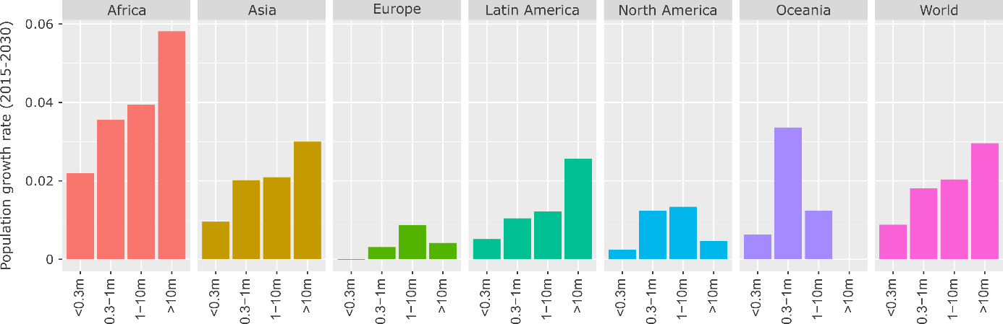

**Figure 1: Projected population growth rate by region and city size, 2015-2030.** Population data from ref 7, using agglomeration data where available.

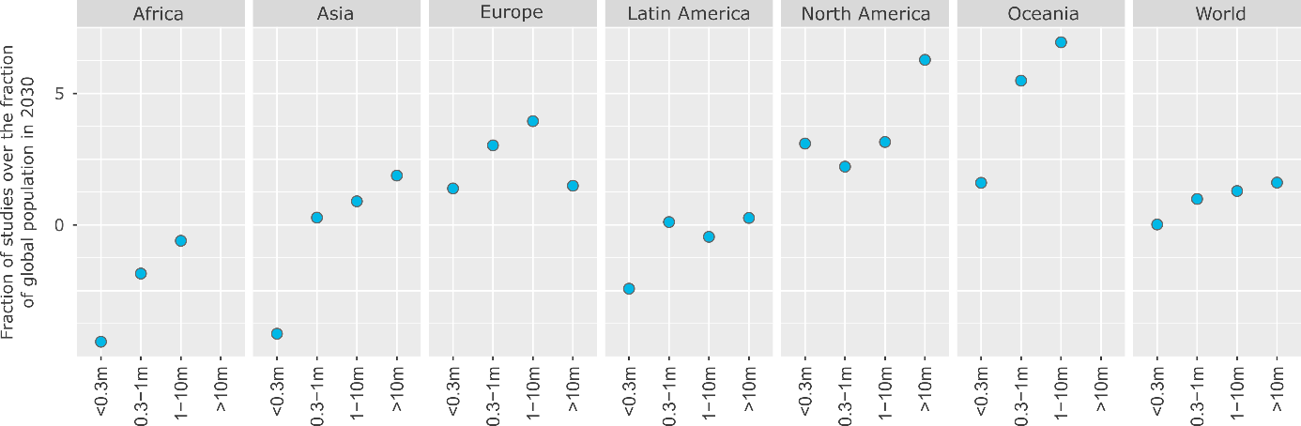

**Figure 2: The global distribution of urban case studies versus population size**. To normalise, where the numerator (% of global population in a region & city size) exceeds the denominator (% of case studies in a region & city size), we subtract the fraction from 2. Population data from ref 7, using agglomeration data where available.

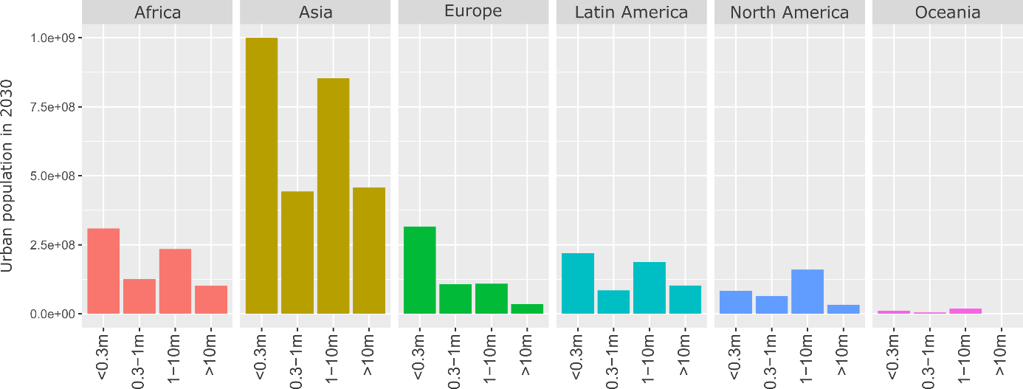

**Figure 3: Total urban population in 2030 by region and city size.** Population data from ref 7, using agglomeration data where available.

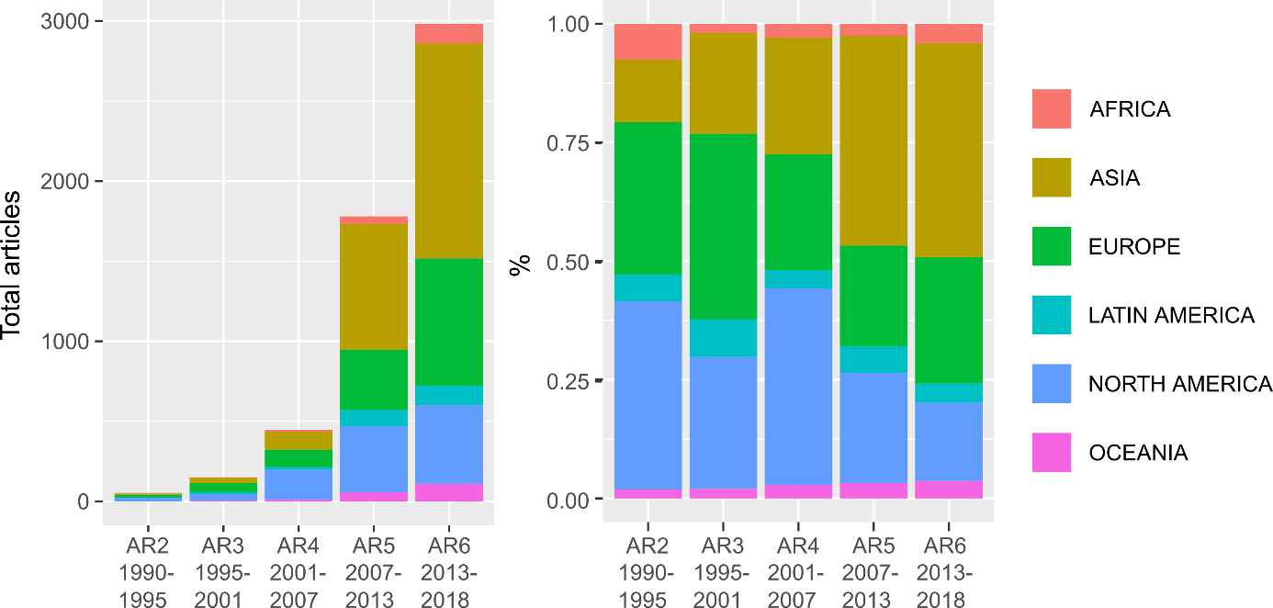

**Figure 4: Total articles and regional proportions of case study literature by IPCC Assessment Period**

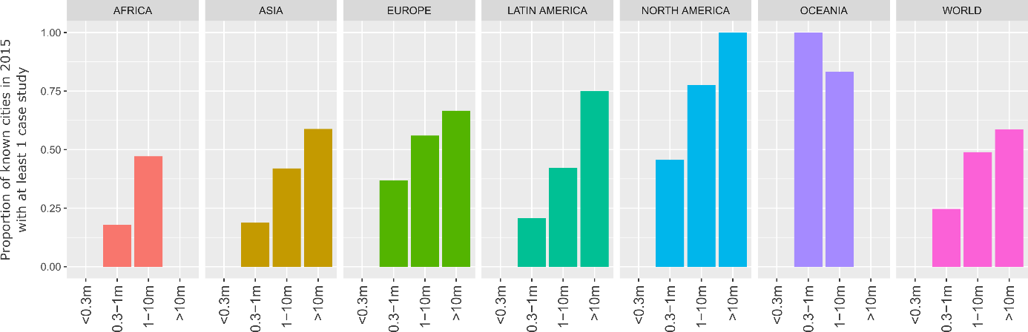

**Figure 5: Direct coverage of case studies.** Missing values for small cities are due to absent data; missing values for mega-cities (Africa, Oceania) indicate no documented mega-cities in these regions as of 2015. Population data from ref 7, using agglomeration data where available.

|  |  |  |  |
| --- | --- | --- | --- |
| **ID** | **Topic Name** | **Stemmed Keywords** | **Marginal Topic Distribution (%)** |
| 1 | Climate governance | climat; chang; polici; local; govern | 8.2 |
| 2 | Energy consumption | energi; consumpt; effici; sector; renew | 7.8 |
| 3 | Urban form | urban; area; land; plan; ecolog | 6.9 |
| 4 | CO2 emissions | carbon; emiss; industri; low; intens | 6.4 |
| 5 | Buildings | build; design; residenti; energi; retrofit | 6.3 |
| 6 | Air pollution | air; pollut; qualiti; health; concentr | 5.6 |
| 7 | GHG emissions | emiss; ghg; greenhous; reduct; inventori | 5.6 |
| 8 | Transportation | transport; traffic; travel; public; car | 5.2 |
| 9 | Vehicles | vehicl; electr; fuel; charg; batteri | 4.9 |
| 10 | Cooling demand | roof; cool; temperatur; thermal; climat | 4.8 |
| 11 | Renewable energy | solar; power; wind; renew; electr | 4.7 |
| 12 | Households | household; incom; behavior; survey; resid | 4.6 |
| 13 | Waste management | wast; landfil; solid; recycl; msw | 4.4 |
| 14 | Heat demand | heat; district; demand; pump; thermal | 4.3 |
| 15 | Water demand | water; suppli; treatment; wastewat; manag | 4.1 |
| 16 | Urban ecology | tree; forest; benefit; speci; plant | 3.2 |

**Table 1: List of topics and their keywords.** Topic names are manually coded by the authors based on a review of the stemmed keywords and associated documents. The marginal topic distribution denotes the percentage of the document set where this topic is found. Two topics were manually removed, due to the marginal information they provided.

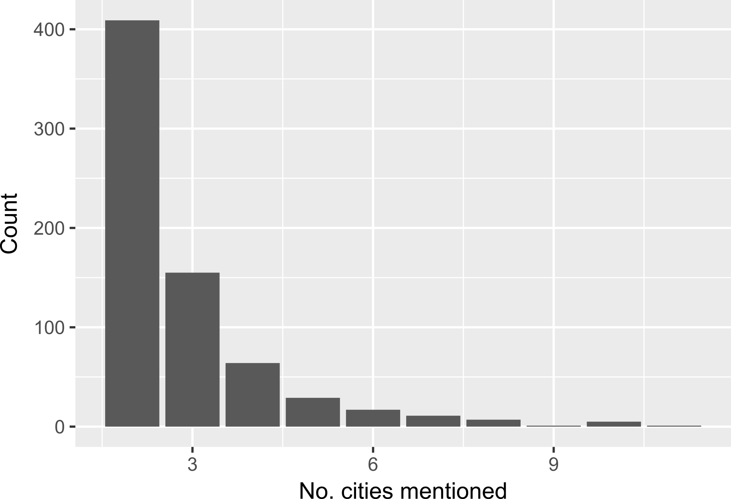

Figure 6: Number of cities mentioned in comparative studies

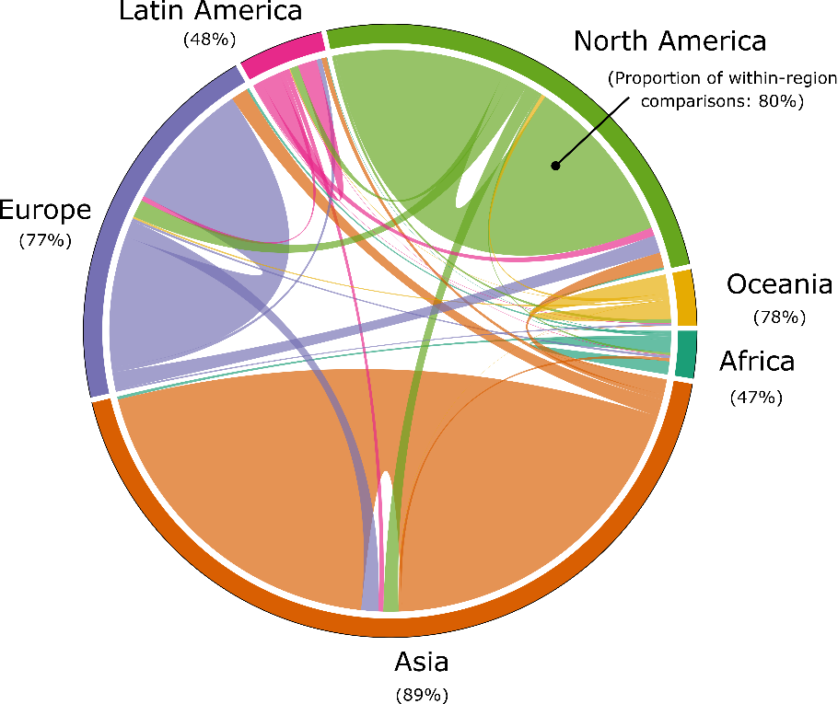

**Figure 7: Inter and intra-regional comparative research on urban climate mitigation.** Each link in the chord diagram is based on the pairwise coupling of two cities within a document. Documents where more than one city is mentioned in the abstract are used, totalling 699 studies. The proportion of regional couplings that pair with other regions (i.e. inter-regional urban comparisons) are indicated as percentages.

|  |  |  |  |
| --- | --- | --- | --- |
| **Authors** | **Year** | **Title** | **Topics** |
| Khalil, H.A.E.E. | 2009 | Energy efficiency strategies in urban planning of cites | Buildings; Climate governance; energy use; urban form |
| Attia, S & De Herde, A | 2010 | Active solar retrofit of a residential house, A case study in Egypt | Buildings; Heat demand; Cooling demand; Renewable energy |
| Fahmy, M & Sharples, S | 2011 | Urban form, thermal comfort and building CO2 emissions - a numerical analysis in Cairo | Buildings; GHG emissions; Cooling demand; Urban form |
| El-Deeb, K, El-Zafarany, A & Sherif, A | 2012 | Effect of building form and urban pattern : On energy consumption of residential buildings in different desert climates | Buildings; Urban form |
| Verdeil, E, Arik, E, Bolzon, H & Markoum, J | 2015 | Governing the transition to natural gas in Mediterranean Metropolis: The case of Cairo, Istanbul and Sfax (Tunisia) | Climate governance; Energy use; Heat demand; Renewable energy; Urban form |
| Dabaieh, M, Wanas, O, Hegazy, MA & Johansson, E | 2015 | Reducing cooling demands in a hot dry climate: A simulation study for non-insulated passive cool roof thermal performance in residential buildings | Buildings; Cooling demand |
| Kares, M & Singh, P | 2016 | Assessment of building integrated photovoltaics for the residential section in representative Urban areas in Egypt | Buildings; Energy use; Households; Renewable energy; Urban form |
| Aboulnaga, M. | 2016 | High-rise buildings in context of sustainability; urban metaphors of greater Cairo, Egypt: A case study on sustainability and strategic environmental assessment | Buildings |
| Chen, H &  Dietrich, U | 2017 | Land-use planning for zero-energy-buildings: Comparison of four high-density cities | Energy use; Urban form |

**Table 2: Urban climate mitigation literature on Cairo**

|  |  |  |
| --- | --- | --- |
| **Title** | **Method** | **Reference** |
| Green roofs against pollution and climate change. A review | Narrative review | [41] |
| Urban and peri-urban agriculture and forestry: Transcending poverty alleviation to climate change mitigation and adaptation | Narrative review | [42] |
| Prospects and challenges for sustainable sanitation in developed nations: a critical review | Narrative review | [43] |
| A meta-analysis of urban and peri-urban agriculture and forestry in mediating climate change | Narrative review | [44] |
| A review on co-benefits of mass public transportation in climate change mitigation | Narrative review | [45] |
| What do we know about the study of distributed generation policies and regulations in the Americas? A systematic review of literature | Bibliometric study | [46] |
| Co-benefits of greenhouse gas mitigation: a review and classification by type, mitigation sector, and geography | Bibliometric study & narrative review | [47] |
| Benefits of green roofs: A systematic review of the evidence for three ecosystem services | Quantitative synthesis | [37] |
| Assessing the success of electricity demand response programs: A meta-analysis | Meta-analysis | [36] |
| The economic benefits and costs of trees in urban forest stewardship: A systematic review | Bibliometric study, quantitative synthesis & narrative review | [38] |

**Table** 3**:** **Systematic reviews of urban climate change mitigation.** The minimum criteria for a ‘systematic review’ here is the formal selection of literature via a database search query. Some reviews (36,46,47) focus on non-urban issues, but derive important conclusions for scientific learning at urban scale, and thus should be included in the relevant literature base on urban-scale climate change mitigation. See methods for our identification procedure.

|  |  |  |  |
| --- | --- | --- | --- |
|  |  |  |  |
|  |  |  |  |
| **Topic** | **Proportion (%)** | **Topic** | **Proportion** |
| GHG emissions | 9.6 | Waste management | 5.5 |
| Climate governance | 8.9 | Vehicles | 4.3 |
| Energy consumption | 8.3 | Heat demand | 3.9 |
| Transportation | 7.5 | Renewable energy | 3.8 |
| Air pollution | 7.5 | Water demand | 3.5 |
| CO2 emissions | 6.9 | Urban ecology | 2.9 |
| Buildings | 5.8 | Cooling demand | 2.7 |
| Urban form | 5.7 | Households | 2.6 |

**Table 4: Topic proportions of 'forward-looking' case studies**

|  |  |  |  |
| --- | --- | --- | --- |
| **Region** | **No. case studies** | **No. ‘forward-looking’ studies** | **Proportion (%)** |
| Africa | 158 | 12 | 8 |
| Asia | 1934 | 335 | 17 |
| Europe | 1145 | 227 | 19 |
| Latin America | 206 | 37 | 18 |
| North America | 1054 | 131 | 12 |
| Oceania | 151 | 23 | 15 |

**Table 5: Regional coverage of 'forward-looking' case studies**